Background Information;

Microsoft’s requests MSDC to track all the shipments for given 121 SKUs list. The tracking is from 940 drop in date till POD date as below milestone;
    - 940/order drop into BAX date
- Pick up from MSDC
- Wheel-Off (ETD)
- Arrival @ Destination Port
- Custom Clearance Delivery Schedule
- POD

  - Reporting: To provide daily report to MS Extranet with the information below;
    - DO#, SO#, PO#, W/H Picktet#BL#/HAWB#, MAWB#
    - Cnee key, Shipto Key,Ship To Cty, FF,
    - Date of order, date of Release to FF, Date of wheel-off, Date of ATA, Date of Custom Clearance, Date of POD.
    - Above report ONLY applied to 121 SKU list given.

Requirement

- Apollo Intelligence.
The whole phase of the tracking and event management will be done in Apollo Intelligence and should be in production in mid Feb 2006. But for manual tracking from now till mid-Feb 06, Bax Singapore IT need to delivery below report to help MSDC in manual tracking and event management of Eval SKUs.

- Ad-Hoc report in Morph (under “Daily Report” tab).
Report should select all the orders contained SKU that found in 121 SKUs given. If the order detail contain one of the SKU found in the 121 SKU list, report will be display with following fields;

DO#(orders/externorderkey),
SO# (orders/SO),
PO#(orders/ BuyerPO),
W/H Picktet# (wave key)
BL#/HAWB# (orderdetail/ MBOLKey),
MAWB#
Cnee key (orders/ConsigneeKey),
Shipto Key(orders/ ShipToKey),
Ship To Cty(orders/S_Country),
FF (orders/PE),
Date of order (orders/adddate),
date of Release to FF(orders/date2),
Date of wheel-off,
Date of ATA,
Date of Custom Clearance,
Date of POD.

Below is the 121 SKU list given;
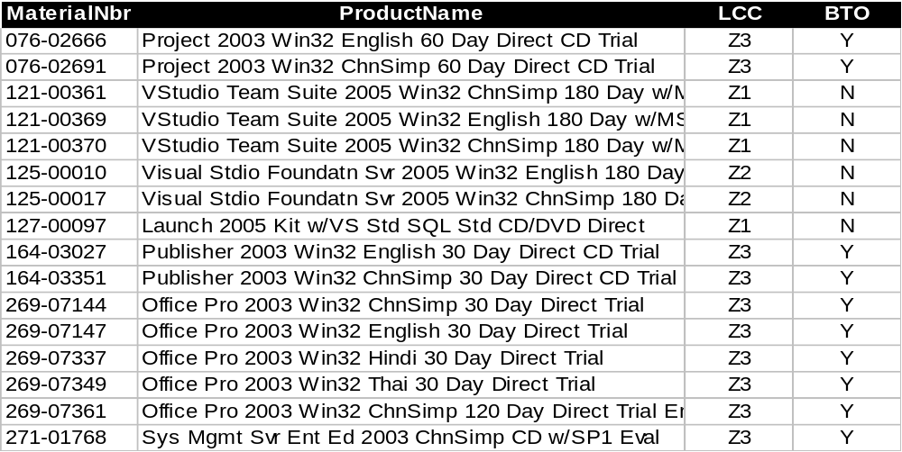

- WO# and Lottable01. (2nd Sep 2005)
The WO# given by MTV is 20 char after added “NZ” instead of 18 char (normal). So need to extend the fields “Lottable01”, “Lottable02” and “Lottable03” fields in database to allow complete WO# into the system.

RF screen for receiving;
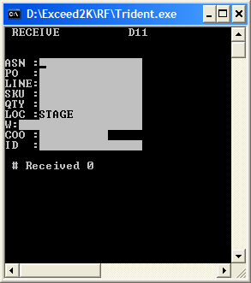

So changes will be below;
- Database: fields “Lottable01-3” in both table Receiptdetail and Lotattribute need to extend to 25 char.
- RF screen need to extend to 25 char.
- Store procedure and trigger need to extend for “lottable01-3”.
- All the “lottable01-3” fields for screen and report used in Morph (hub) need to be extended.
- All the “lottable01-3” fields used in Exceed (WMS) need to be extended.

